API Response

🌐 What is an API Response
# Source: AI Source: Provided by: [Data Path: Persons Table -> ID Column: 1, Name_En Column: Motasem Essam] -> From: [ChatGPT] on [1/19/2026]
An API Response is the data sent back by the server to the API client after processing a request. It communicates the result of the request, including data, status, and errors.
👉 Think of the API Response as the answer from the server to the client’s request.

🔑 Key Components of an API Response
# Source: AI Source: Provided by: [Data Path: Persons Table -> ID Column: 1, Name_En Column: Motasem Essam] -> From: [ChatGPT] on [1/19/2026]
- Status Code – Indicates the result of the request
  - 200 OK → Success
  - 201 Created → Resource created
  - 400 Bad Request → Client error
  - 404 Not Found → Resource not found
  - 500 Internal Server Error → Server error
- Headers – Provide metadata about the response
  - Content-Type: application/json
  - Cache-Control, Authorization, etc.
- Body – The actual data or message returned
  - Usually JSON or XML

🧱 Example: Successful Response
# Source: AI Source: Provided by: [Data Path: Persons Table -> ID Column: 1, Name_En Column: Motasem Essam] -> From: [ChatGPT] on [1/19/2026]
Request
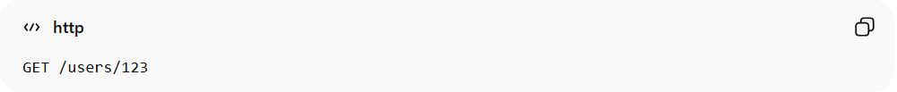
GET /users/123
Response (200 OK)
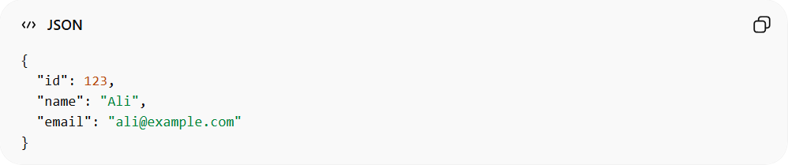
{
"id": 123,
"name": "Ali",
"email": "ali@example.com"
}

🧱 Example: Error Response
# Source: AI Source: Provided by: [Data Path: Persons Table -> ID Column: 1, Name_En Column: Motasem Essam] -> From: [ChatGPT] on [1/19/2026]
Request
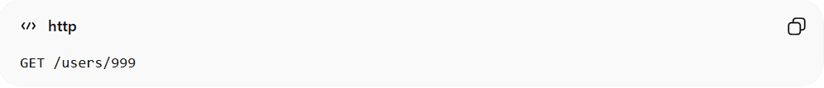
GET /users/999
Response (404 Not Found)
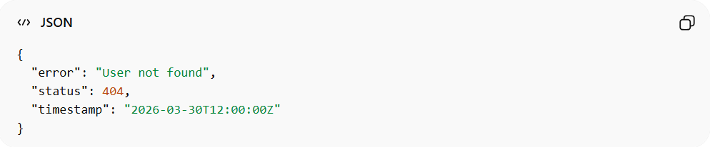
{
"error": "User not found",
"status": 404,
"timestamp": "2026-03-30T12:00:00Z"
}

✅ Best Practices for API Responses
# Source: AI Source: Provided by: [Data Path: Persons Table -> ID Column: 1, Name_En Column: Motasem Essam] -> From: [ChatGPT] on [1/19/2026]
- Always return appropriate HTTP status codes
- Include meaningful messages for errors
- Use consistent response format across endpoints
- Avoid returning sensitive information in error messages

❌ Common Mistakes
# Source: AI Source: Provided by: [Data Path: Persons Table -> ID Column: 1, Name_En Column: Motasem Essam] -> From: [ChatGPT] on [1/19/2026]
- Returning 200 OK for errors ❌
- Mixing different data formats in the API ❌
- Sending raw database objects without formatting ❌

💡 Summary
# Source: AI Source: Provided by: [Data Path: Persons Table -> ID Column: 1, Name_En Column: Motasem Essam] -> From: [ChatGPT] on [1/19/2026]
An API Response is the server’s structured reply to a client request, including status, headers, and body.

